PRESS RELEASE

COMMUNICATIONS AND MEDIA TEAM OF THE 43rd ASEAN SUMMIT 2023

No.31/SP/TKM-ASEAN2023/ENG/9/2023

Indonesia Promotes ASEAN Media Cooperation to Enhance ASEAN Awareness

Jakarta, 1 September 2023 – Through Indonesia's initiative, several representatives of the state news agencies of ASEAN member countries have agreed to continue developing cooperation to enhance the understanding of the region's population regarding ASEAN policies and initiatives

The Forum Between News Agencies, initiated by LKBN ANTARA in collaboration with the Indonesian Ministry of Foreign Affairs and the Indonesian Ministry of Communication and Informatics, was held online on Friday (1/9/2023).

The forum featured Luis A. Morente, Director of the News and Information Bureau of the Philippines News Agency; Mohd Iswandi, Head of Bureau of Bernama Malaysia; Paul Ravi, Senior Editor of International News at Bernama; Manuel Pinto, President of the Executive Board of Timor Leste News Agency, and representatives from other news agencies.

"Collaboration among ASEAN media is crucial to be continuously improved to further open channels of communication among countries in the region through conventional, mainstream, and new media," said Irfan Junaidi, Director of News at LKBN ANTARA.

Throughout Indonesia's chairmanship of ASEAN in 2023, Indonesia has been encouraging collaboration among ASEAN news agencies through various channels and opportunities.

"Information and communication technology has advanced significantly since the official media collaboration in ASEAN in 1989 during The First Conference of ASEAN Ministers Responsible for Information. We must harness these developments to enhance ASEAN awareness holistically," said Hartyo Harkomoyo, Director for Information and Media at the Indonesian Ministry of Foreign Affairs.

One of the concrete implementations of this collaboration in the near future is the inauguration of the ASEAN Newsroom Corner at the Media Center of the 43rd ASEAN Summit. In addition, capacity building and training will also be conducted, including workshops, conferences, and competitive activities. Moreover, the implementation of the ASEAN Communication Master Plan (ACMP) II (2018-2025) will serve as a framework for disseminating messages about ASEAN's vision and promoting the ASEAN Community.

In this ever-evolving era, one form of implementation discussed in this forum is the amplification of the use of new media platforms such as podcasts, webinars, and videos to inspire ASEAN citizens to become more involved in building all pillars of the ASEAN community.

***

For further information, please contact the following:

Director for Information and Media at the Indonesian Ministry of Foreign Affairs – Hartyo Harkomoyo (0811831899)

Get more information at http://asean2023.id, https://infopublik.id/kategori/asean-2023, dan https://indonesia.go.id/kategori/ragam-asean-2023

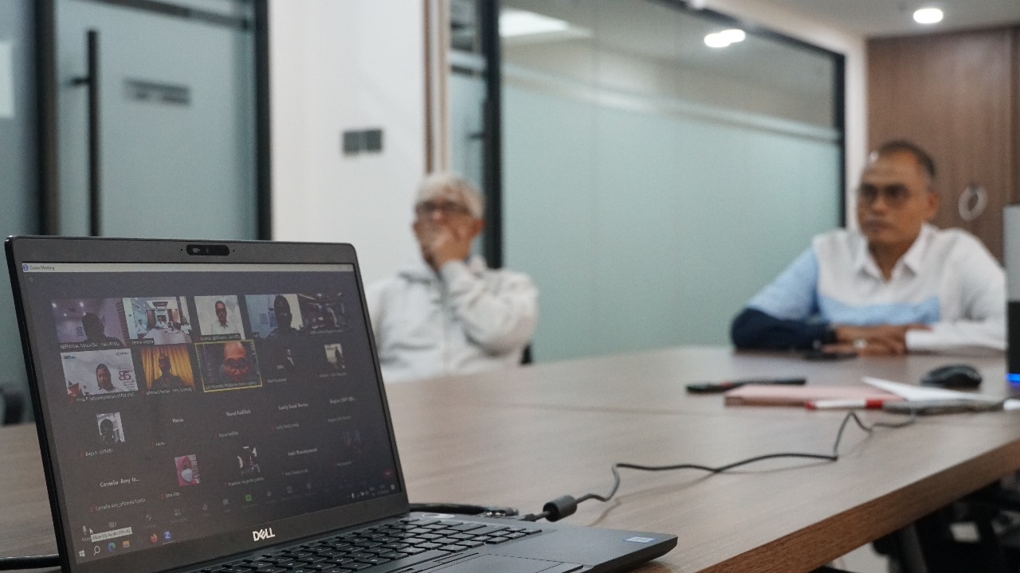

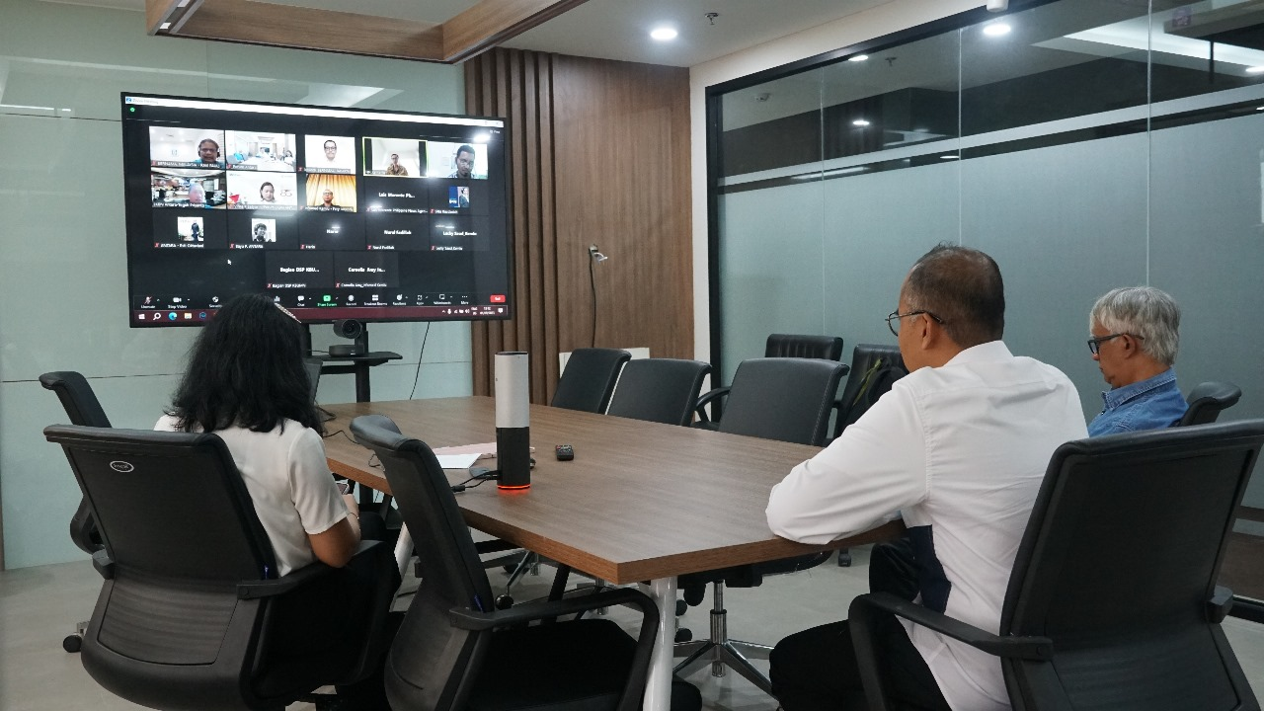

Coordinating Forum for ASEAN News Agency with LKBN Antara, Ministry of Foreign Affairs, and Ministry of State-Owned Enterprises. During Indonesia's chairmanship of ASEAN in 2023, Indonesia continues to promote collaboration among ASEAN news agencies through various channels and opportunities (Photo: ANTARA News)

